

**COMSATS University Islamabad**

**Abbottabad, Pakistan**

**Sabzi Mandi Management System**

***By***

**BASIT IQBAL CIIT/FA2021-BSE-050/ATD**

**FATIMA AFTAB CIIT/FA2021-BSE-088/ATD**

**NOOR-UL-AIN CIIT/FA2020-BCS-089/ATD**

***Supervisor*Dr. Rab Nawaz Jadoon**

***Bachelor of Science in Computer Science (2023-2023)***

**The candidate confirms that the work submitted is their own and appropriate  
 credit has been given where reference has been made to the work of others**.



**EXECUTIVE SUMMARY**

In Abbottabad, Pakistan, the collaboration, and management of data between customers, vendors, and supervisors (AC) in the local Sabzi Mandi (vegetable market) have been a major challenge. The existing system of issuing paper-based lists by the AC to vendors often leads to discrepancies, with vendors deviating from the approved list or making unauthorized changes, resulting in unexpected price inflation. Additionally, the lack of proper data storage and analytics hinder effective decision-making by the government.

To address these issues, we propose the development of a comprehensive Sabzi Mandi database system. This system will facilitate seamless collaboration and ensure transparency among all stakeholders. The system will include an administrative interface for the AC, allowing them to upload and manage the approved daily lists. Customers will have access to view the daily list, ensuring they have up-to-date information. Vendors will be provided with the list directly from the database, preventing unauthorized changes.

By implementing this database system, we aim to eliminate data discrepancies, prevent unauthorized modifications to the list, and enhance transparency in the pricing and availability of fruits and vegetables. The centralized database will enable efficient data storage and retrieval, reducing the chances of data loss and facilitating accurate analytics for informed decision-making by the government.

In conclusion, the Sabzi Mandi database system offers a comprehensive solution to the challenges faced in Abbottabad's Sabzi Mandi. By leveraging technology, stakeholders can collaborate effectively, ensuring adherence to approved lists, combating inflation, and enabling data-driven decision-making. This system will revolutionize the Sabzi Mandi operations, benefiting customers, vendors, and the overall economy.

1. **Introduction**

The Sabzi Mandi Management System is a groundbreaking project designed to address collaboration and data management challenges in Abbottabad's Sabzi Mandi. By implementing a centralized database, the project aims to ensure transparency and prevent unauthorized modifications to the daily lists issued by the supervisors (AC). This digital system will empower customers to access the approved list while providing vendors with a secure and unalterable source of information, ultimately improving efficiency and trust within the Sabzi Mandi.

* 1. **Relevance to Course Modules**

The project is implemented by using the different concepts of database system. It is covering all the concepts of data modeling , including ERD diagram , normalization and creating database Schema.

* 1. **Project Background**

In Abbottabad, Pakistan, the collaboration, and management of data between customers, vendors, and supervisors (AC) in the local Sabzi Mandi (vegetable market) have been a major challenge. The existing system of issuing paper-based lists by the AC to vendors often leads to discrepancies, with vendors deviating from the approved list or making unauthorized changes, resulting in unexpected price inflation. Additionally, the lack of proper data storage and analytics hinder effective decision-making by the government.

To address these issues, we propose the development of a comprehensive Sabzi Mandi database system. This system will facilitate seamless collaboration and ensure transparency among all stakeholders. The system will include an administrative interface for the AC, allowing them to upload and manage the approved daily lists. Customers will have access to view the daily list, ensuring they have up-to-date information. Vendors will be provided with the list directly from the database, preventing unauthorized changes.

* 1. **Literature Review**

There are a lot of projects on internet working on this project. But real-life implementation is not available .

1. **Problem Definition**

In Abbottabad, Pakistan, the collaboration, and management of data between customers, vendors, and supervisors (AC) in the local Sabzi Mandi (vegetable market) have been a major challenge. The existing system of issuing paper-based lists by the AC to vendors often leads to discrepancies, with vendors deviating from the approved list or making unauthorized changes, resulting in unexpected price inflation. Additionally, the lack of proper data storage and analytics hinder effective decision-making by the government.

* 1. **Problem Statement**

To address these issues, we propose the development of a comprehensive Sabzi Mandi database system. This system will facilitate seamless collaboration and ensure transparency among all stakeholders. The system will include an administrative interface for the AC, allowing them to upload and manage the approved daily lists. Customers will have access to view the daily list, ensuring they have up-to-date information. Vendors will be provided with the list directly from the database, preventing unauthorized changes.

* 1. **Proposal**

The proposed project aims to develop a comprehensive fruit and vegetable management system specifically designed for Sabzi Mandi in Pakistan. The system aims to streamline operations, enhance productivity, and improve data accuracy. It will transition from manual record-keeping to a digital platform. The system will enable vendors, buyers, and administrators to access real-time information, ensuring transparency and improving decision-making. It will address corruption issues through regular backups and integrity checks. The proposed system modules include price monitoring, AC approves lists , buyers can view daily list. The software requirements for the project include Star UML, Oracle 19c and MySQL. The proposed fruit and vegetable management system for Sabzi Mandi aims to revolutionize operations, improve data accuracy, and increase productivity within the market.

1. **ERD Diagram**
   1. **Level 0 ERD Diagram**

### Description:

In Sabzi Mandi Management System there is a admin. He is responsible to approves the lists of fruit and vegetables daily. One Admin can approve many lists. Approved list can be viewed by customers and given to Vendors. Customers can view one list at the time. One list is given to Vendors daily. Fruit lists and vegetable lists contain many items in it.

### Entities:

* VegeList
* Admin
* Customers
* Vendor
* FruitList
* Items

### Diagram:

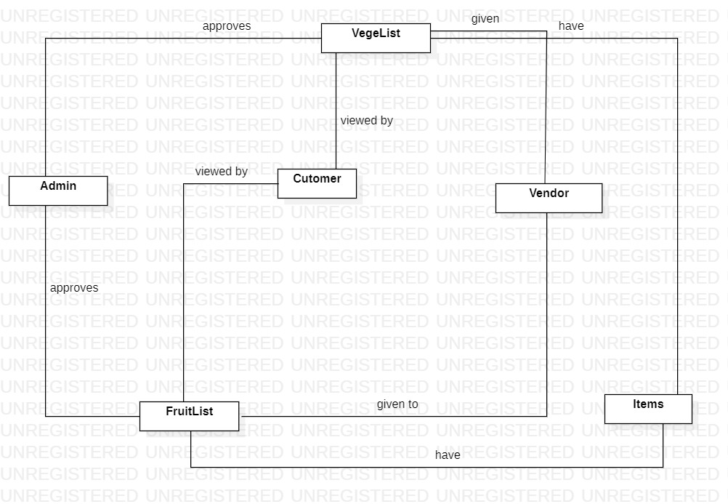

* 1. **Level 1 ERD Diagram**

### Relations:

* Admin can approve one or many list of fruits and vegetables , at least one list of fruit and vegetable can be approved by admin daily.
* Fruits and Vegetables list can be viewed by many customers or may not be viewed by a single customer daily.
* Fruits and Vegetables list can be given to one or many vendors, one vendor gets only one list.
* Fruits and Vegetables lists have at least one or many items, but items can be present in many lists or may not be present in any list.

### Diagram:

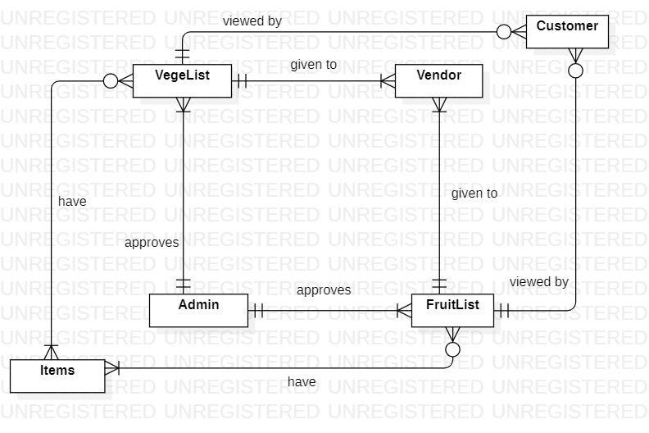

* 1. **Level 2 ERD Diagram**

### Resolve Many to Many Relations Of ERD:

### Diagram

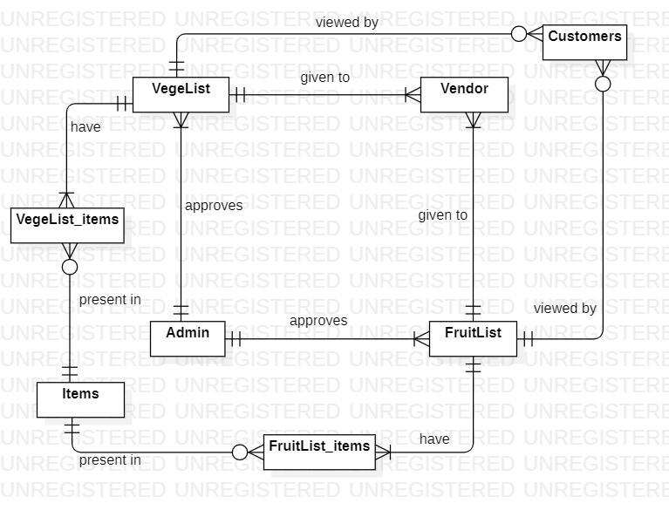

The above description is level 0 of the sabzi management system, It contains many to many relations between entities so to solve those many to many relations we will draw level 1 by entering the gerund entities between those entities which have many to many relations. We will just insert the gerund entity between those entities which have many to many relations and then we will put the primary keys of both the entities into the gerund entity as foreign key .

### Diagram:

## 

1. **Normalization**

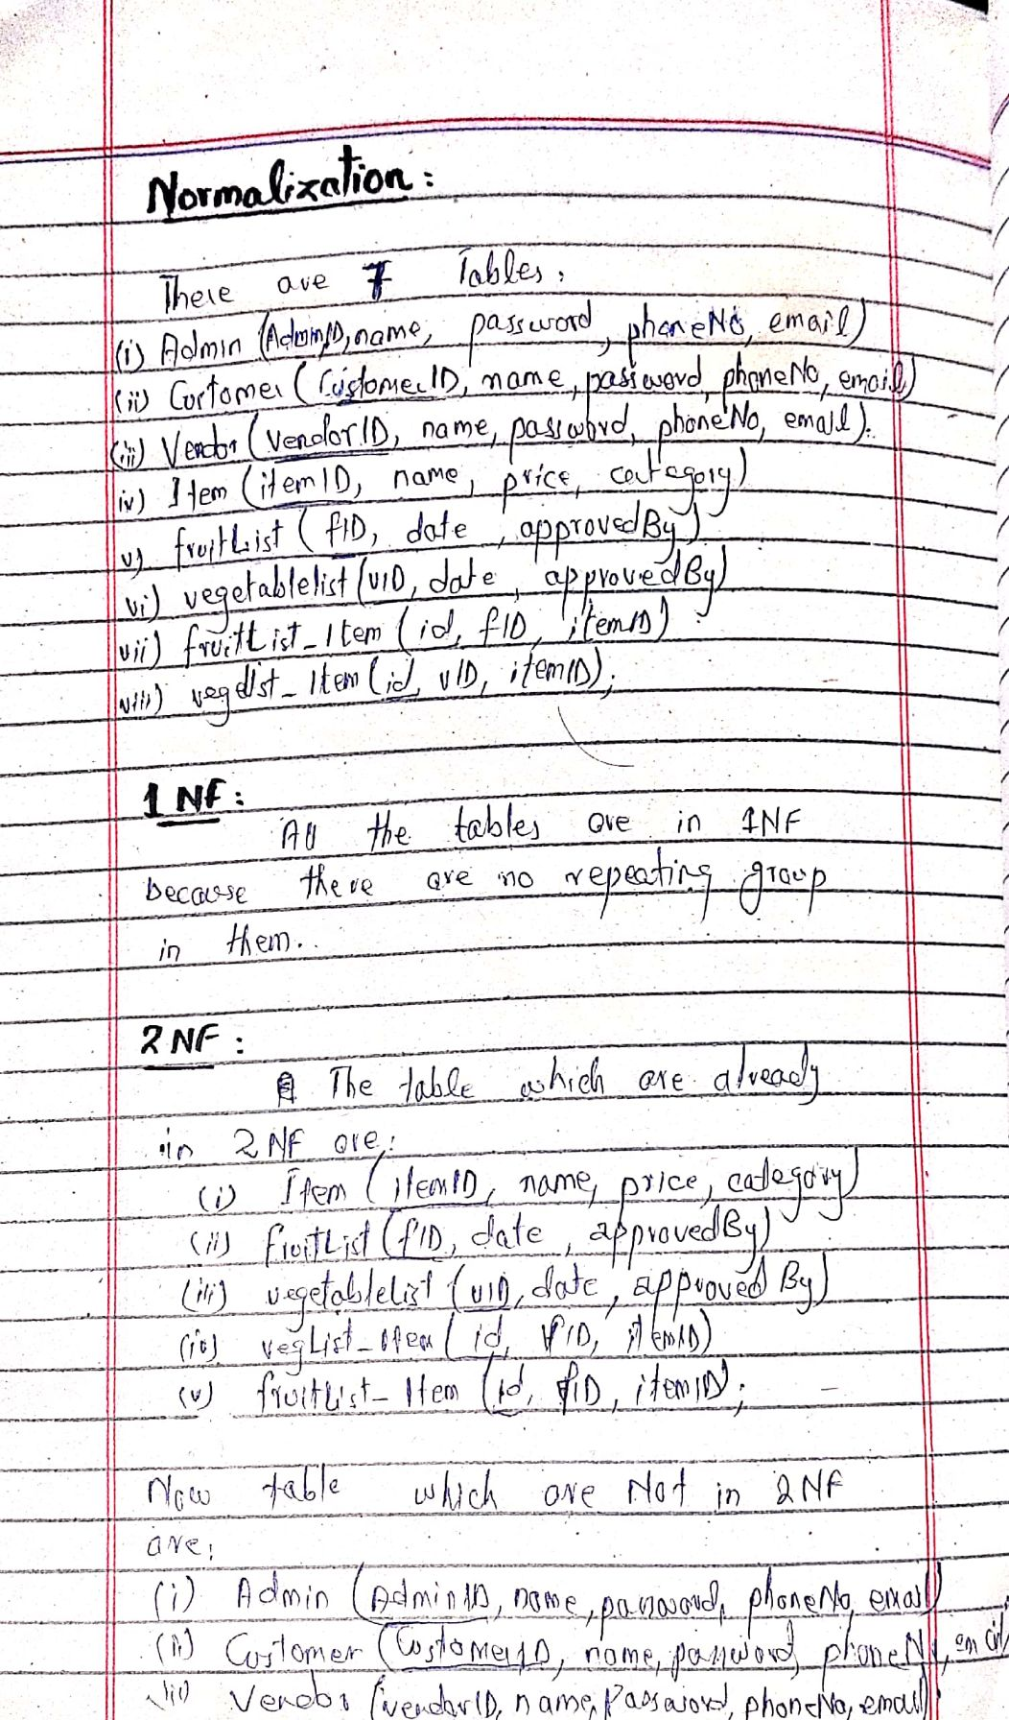

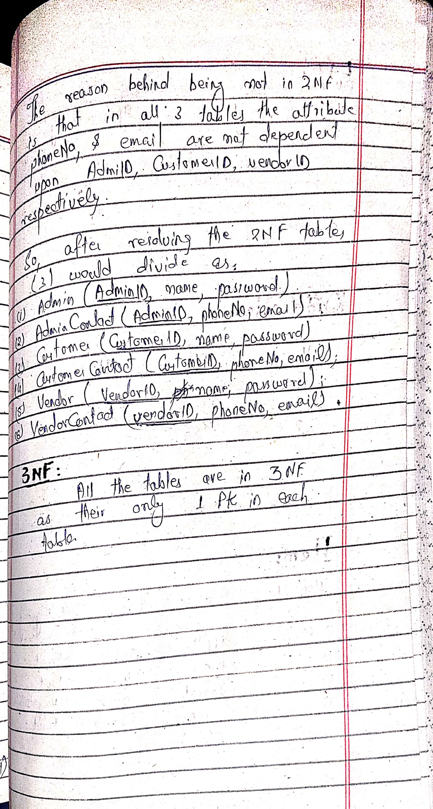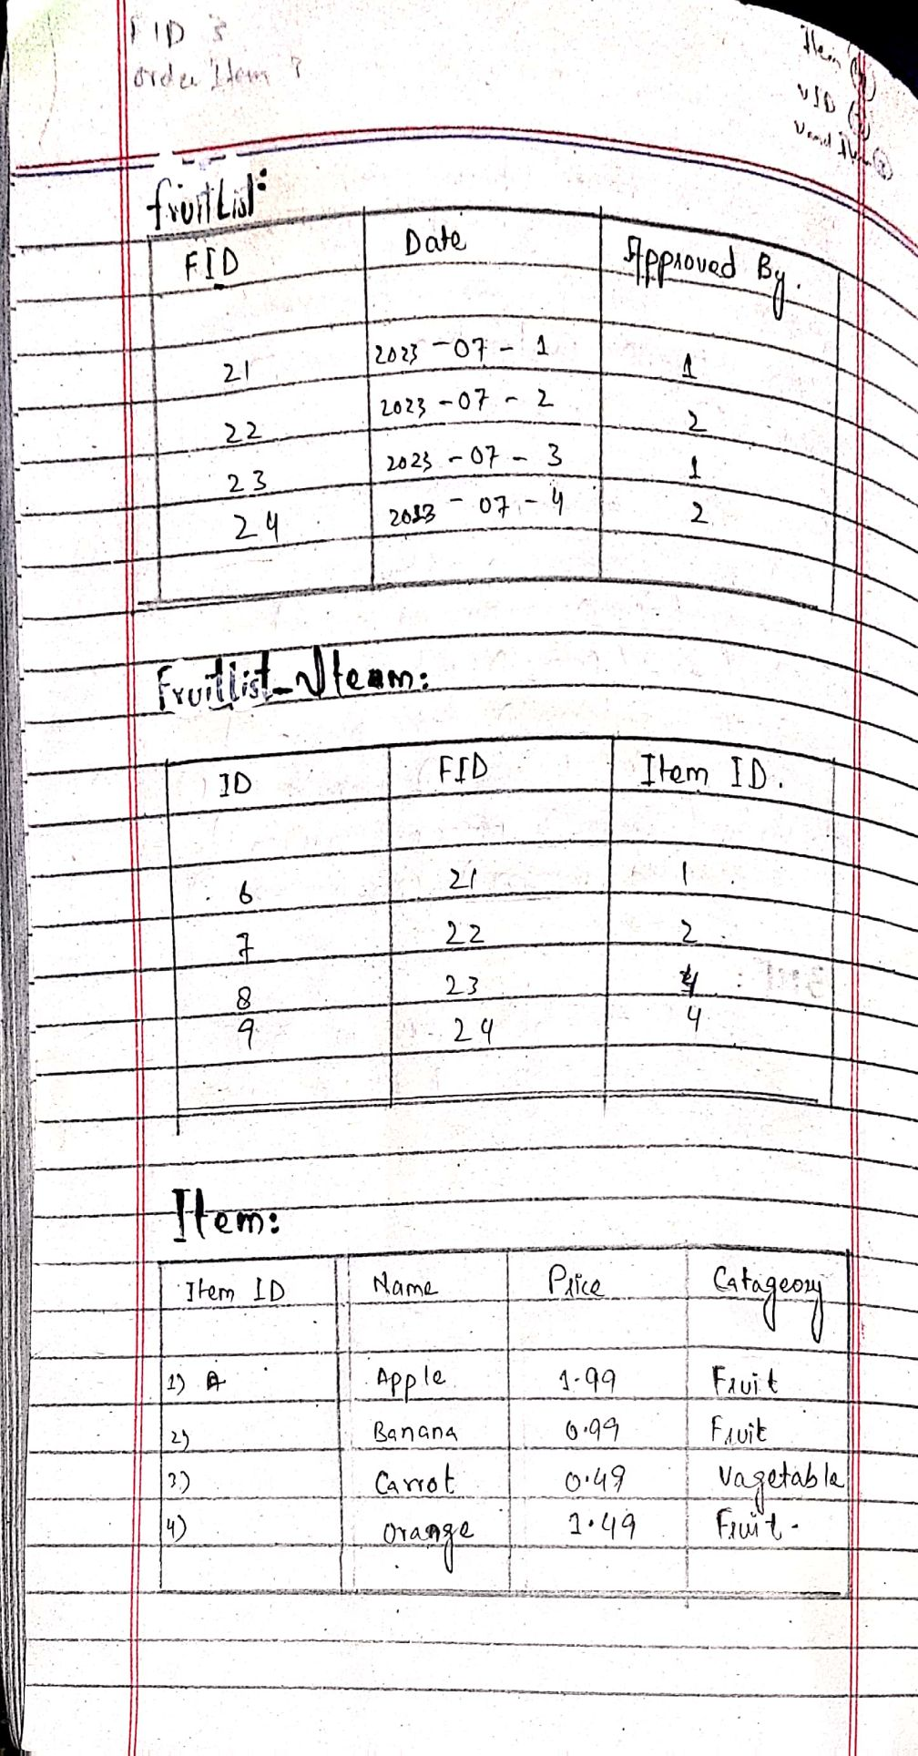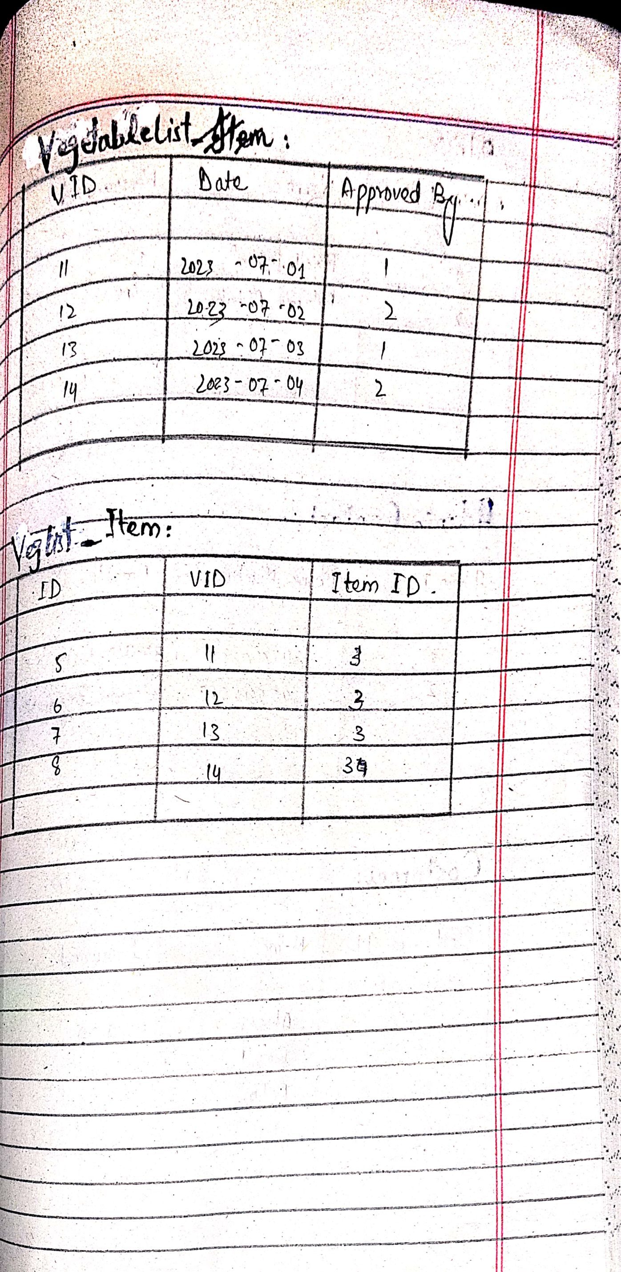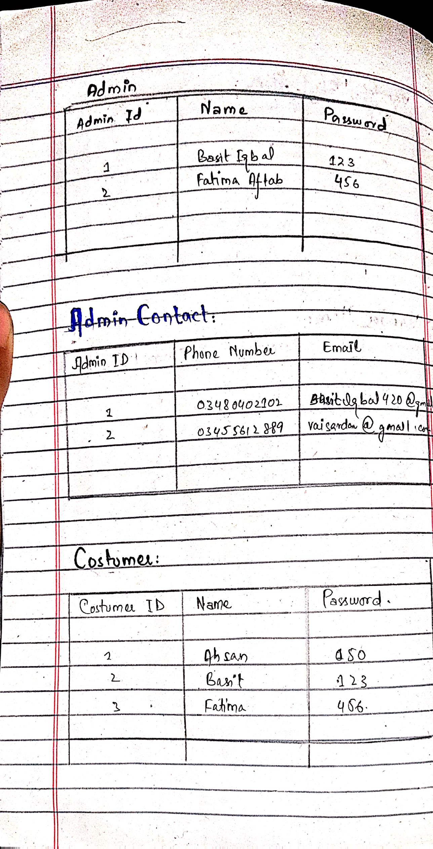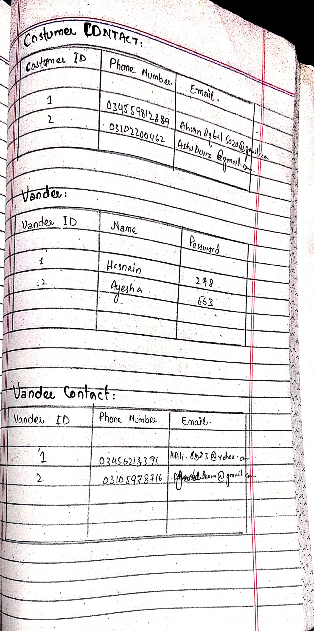

Translation Schema:

**1-Table Name:** Admin

**Primary key:** Adminid

**Description:** This table used to store the names of all Admins

|  |  |  |  |
| --- | --- | --- | --- |
| **Field Name** | **Data Type** | **Size** | **Description** |
| AdminId | INT |  | Admin no |
| name | Varchar | 50 | Name of Admin |
| password | Varchar | 50 | Password of Admin |

**2-Table Name:** AdminContact

**Primary key:** AdminId.

**Foreign key:** AdminId, References Admin (AdminId)

**Description:** This table contains information of Admins contacts

|  |  |  |  |
| --- | --- | --- | --- |
| **Field Name** | **Data Type** | **Size** | **Description** |
| AdminId | INT |  | Admin id |
| PhoneNo | varchar | 20 | Phone number of admin |
| email | Varchar | 50 | Email of admin |

**3-Table Name:** Customer

**Primary key:** Customerid

**Foreign** **key**: VlistID: References VegetableList (vID),

flistID: References fruit List ( fID).

**Description:** This table used to store the names of all Custumers

|  |  |  |  |
| --- | --- | --- | --- |
| **Field Name** | **Data Type** | **Size** | **Description** |
| CustumerId | INT |  | Admin no |
| name | Varchar | 50 | Name of Customer |
| password | Varchar | 50 | Password of Customer |
| VlistID | INT |  | vegetableList id |
| flistID | INT |  | Fruit List id |

**4-Table Name:** CustomerContact

**Primary key:** CustomerId.

**Foreign key:** CustomerId, References Costumer (CustomerId)

**Description:** This table contains information of Customer contacts

|  |  |  |  |
| --- | --- | --- | --- |
| **Field Name** | **Data Type** | **Size** | **Description** |
| CustomerId | INT |  | Admin id |
| PhoneNo | varchar | 20 | Phone number of Customer |
| email | Varchar | 50 | Email of Customer |

**5-Table Name:** Vendor

**Primary key:** VendorId

**Foreign** **key**: VlistID: References VegetableList (vID),

flistID: References fruit List ( fID).

**Description:** This table used to store the names of all Vendors

|  |  |  |  |
| --- | --- | --- | --- |
| **Field Name** | **Data Type** | **Size** | **Description** |
| VendorId | INT |  | Vendor no |
| name | Varchar | 50 | Name of Vendor |
| password | Varchar | 50 | Password of Vendor |
| VlistID | INT |  | vegetableList id |
| flistID | INT |  | fruitList id |

**6-Table Name:** VendorContact

**Primary key:** VendorId.

**Foreign key:** VendorId, References Vendor (VendorId)

**Description:** This table contains information of Vendors contacts

|  |  |  |  |
| --- | --- | --- | --- |
| **Field Name** | **Data Type** | **Size** | **Description** |
| VendorId | INT |  | Vendor id |
| PhoneNo | varchar | 20 | Phone number of Vendor |
| email | Varchar | 50 | Email of Vendor |

**7-Table Name:** vegetableList

**Primary key:** vID.

Foreign key: approvedBy , Refernces Admin(AdminID)

**Description:** This table contains information of Admins contacts

|  |  |  |  |
| --- | --- | --- | --- |
| **Field Name** | **Data Type** | **Size** | **Description** |
| vID | INT |  | vegetableList id |
| date | date |  | Date of issue |
| approvedBy | INT |  | Admin id |

**8-Table Name:** fruitList

**Primary key:** fID.

**Foreign** **key**: approvedBy , Refernces Admin(AdminID)

**Description:** This table contains information of Admins contacts

|  |  |  |  |
| --- | --- | --- | --- |
| **Field Name** | **Data Type** | **Size** | **Description** |
| fID | INT |  | fruitList id |
| date | date |  | Date of issue |
| approvedBy | INT |  | Admin id |

**9-Table Name:** items

**Primary key:** itemID.

**Description:** This table contains information of Admins contacts

|  |  |  |  |
| --- | --- | --- | --- |
| **Field Name** | **Data Type** | **Size** | **Description** |
| itemID | INT |  | item id |
| name | Varchar | 50 | Name of item |
| price | INT |  | Price of a particular item |
| category | varchar | 50 | Fruit or vegetable |

**10-Table Name:** fruitlist_items

**Primary key:** ID.

**Foreign key:** fID, References fruitlist(fID),

itemID References item(itemID).

**Description:** This table is an gerund entity that is made to solve the many to many relationship.

|  |  |  |  |
| --- | --- | --- | --- |
| **Field Name** | **Data Type** | **Size** | **Description** |
| id | INT |  | item id |
| fID | INT |  | Fruitlist id |
| itemID | INT |  | Item id |

**11-Table Name:** veglist_items

**Primary key:** ID.

**Foreign key:** vID, References vegetablelist(vID),

itemID References item(itemID).

**Description:** This table is an gerund entity that is made to solve the many to many relationship.

|  |  |  |  |
| --- | --- | --- | --- |
| **Field Name** | **Data Type** | **Size** | **Description** |
| id | INT |  | item id |
| vID | INT |  | Vegetablelist id |
| itemID | INT |  | Item id |